Compare your 411 from when you printed tax bills (Seen Below on the left) to a current 411 (seen on the right).
When you make changes to your grand list print a 411 report and compare the values.

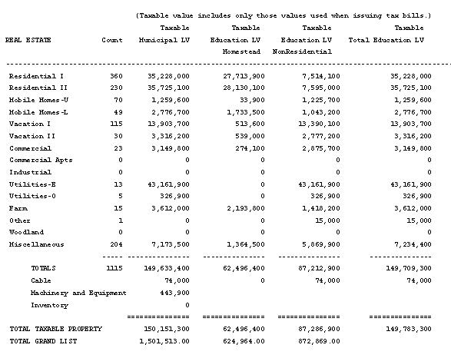
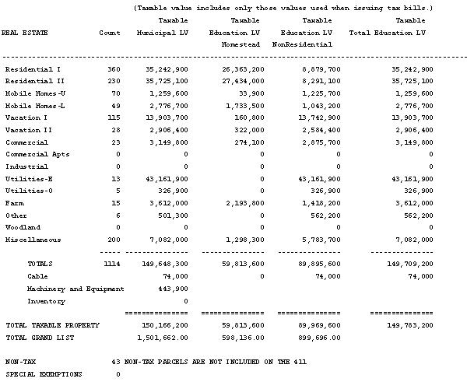

Compare your tax book summary page from when you printed tax bills to the current tax book in your as billed grand list entity. Remember – if tax bills were printed on a computer that is not connected to your computer you should run these reports from the computer that tax bills were printed and maintained.

